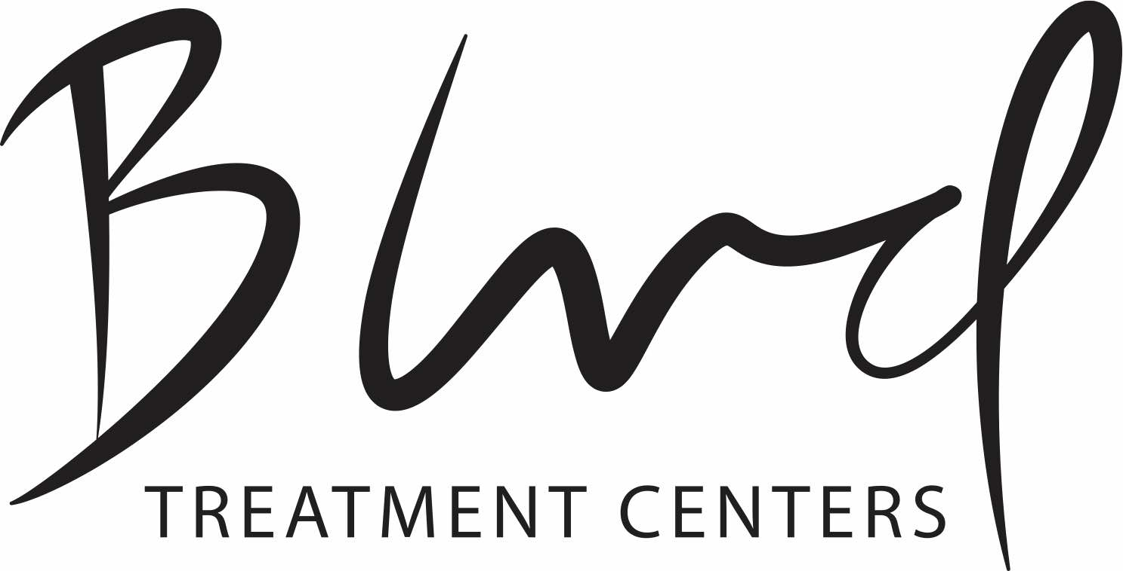

Letter from Family Member to their Loved One.
Building a Sober Future and Keeping Safe Boundaries.

The following is a format that can be used as a guide. Please read the boundaries hand out #1 and the Stop Enabling, Start Empowering hand out before writing this letter. All the questions do not need answered below. They are writing points to consider.

It can be as long or short as you want. Please consult with BLVD’s Licensed Clinical Social Worker and Clinical Director prior to presenting letter in a family session. Email letter for feedback to j.lucero@blvdtreatmentcenters.com. Jeff Lucero will look over and let you know any suggestions for how your loved one may receive the information.

Family sessions can be done with your family member in treatment, Jeff Lucero (Clinical Director) and your loved ones Primary Therapist via phone, video conference or in person. It is important to remember that your loved ones recollection of the past or things they have done while under the influence maybe slightly foggy, a complete blank or they may have created a story to cover up the actual events. That is ok. That is normal. It is not important to remind them of all their past wrongs or inconsistency. It IS important that you let them know you will not be contributing to their addiction anymore. Many parents or spouses are afraid that if they do this they cannot follow through or will drive the alcoholic or addict deeper into the spiral. That belief is exactly what will continue to enable your loved one to drink or use drugs. Alcoholics and addicts stop when they want to; the illusion that you can control, explain or rationalize with an alcoholic/addict. These feelings and the resulting actions only contribute to your loved one continuing to drink and use drugs. There is no amount of love, compassion, anger, guilt, intellectualizing, using incentives or explaining how to just stop that will stop an alcoholic/addict that does not want to stop. OUR job at BLVD is to lay the foundation of real sobriety through individual sessions, group therapy, medical support, relapse prevention skills, addiction and alcoholism education, PRACTICE of skills in everyday life and return to BLVD to process, mental health therapy, mindfulness DBT skills, trauma/ptsd processing, support, fun in recovery, rebuilding healthy family connection so that any alcoholic/addict that engages in treatment has the ability to stay sober for their lifetime. OUR job is to teach your loved one so much about recovery and themselves that they cannot return to their old life style of substance use without struggling with the knowledge of a better life.

YOUR job is to follow the direction of professionals. It is very easy to be pulled in to an alcoholic or addicts chaos and just because they are substance free does not mean the maladaptive skills and behaviors they have developed disappear. YOUR job is to stay aligned with the family being healthy and supporting your loved one through keeping boundaries. Remember that each time you indulge, supply money or give the alcoholic/addict a way out of facing the recovery process it contributes to them staying sick. When spouses or family do this we inevitably see personal growth and recovery take hold of that Client. YOUR job is to not re-hash the past, impose your personal beliefs about addiction and will power, guilt or complain to the person in treatment or advise your loved one on how to be sober but instead to lend YOUR support treatment to the treatment team and hold boundaries in place.

Dear __________________________,

In the past I have not had appropriate boundaries with you and your alcoholism/addiction. This was not because I wanted to enable you; I was trying to help you. Now that you are in recovery I want to support you in the right ways and tell you my boundaries for the future. These boundaries are not a threat or a punishment in case you relapse. I want to set boundaries for now and so that in the future I do not enable you to use return to alcohol or drugs use. I want to empower your recovery and not put myself or you in a position to be hurt by addiction ever again. I have been advised by BLVD it is better to set healthy boundaries now, not later. I recognize that I have not always been the best ______________. I accept and ask you to forgive me for _____________________________________________________
___________________________________________________________.

In our future I need the following things from you. I want to use this letter as our guide if we need it. I want to be healthy along with you and not trigger you or enable you.

Treatment graduation and compliance? Please write what you need from your loved one to do while in treatment. (graduate, stay in sober living, follow rules?)

_________________________________________

Alcohol and Drug screens are the UNBIASED tool used by all providers and the best way to see if someone is sober. While I want to be able to know you are sober I recognize that ANYONE can be misled and I need the support of the tool of alcohol and drug screens. My boundary and expectation is:

_____________________________________________________

Mental Health Therapy/Medication compliance or attendance?

_________________________________________

If you need mental health help or support I need you to do this?

________________________________________________

What I think it looks like and how I will know to trust you and that you are really changing?

__________________________________________________

12 step meeting support group attendance and sponsorship?

___________________________________________________

Monitary support? What is your expectation of loved one?
Cell phone?

_________________________________________________

Living environment? What is most comfortable for you to maintain boundaries with loved one and build trust?

_________________________________________________

Relapse:

It is imperative you set boundaries before a relapse. Relapse is not part of recovery and is not expected of anyone. However, it does happen. It is better to set up how you will respond now so there is no surprises later should that happen. Often people struggling with alcohol or drugs sabotage treatment, build resentments or cast things in a negative light to get the “cooperation” of the family. To be successful a family must be clear that they know this and will not be misled.

If you relapse or sabotage treatment by breaking rules, getting discharged or intentionally leaving creating a treatment ending incident. These are my boundaries:

Can they come to your home? _______________________ (Suggested response is NO.)

Will you buy them food? ____________________________ (Yes if can do so in a safe way.)

Will you give them money? _________________________ (Suggested response is NO.)

Bail out of jail? ____________________________________

Pay fines? ________________________________________

Pay bills? ________________________________________

Will you “cover” for them to Probation, Court, Significant others, Children, Treatment, DHS/Child Custody or to other family?

________________________________________________________

How will you support yourself in being heathy with boundaries and still support your loved one in getting sober again without becoming sick with your loved ones alcoholism or addiction?

_________________________________________________________

Can they call you? What are perimeters of talking if loved one is using?

_______________________________________________________

What are boundaries around children? These can be Client’s children or nieces, nephews, siblings..?

___________________________________________________________

What has it been like for YOU when your loved one has relapsed or been using?
What were your thoughts and feelings?

____________________________________________________________

What did you experience?

____________________________________________________________

Statement of Love: Explain your love to the person receiving this letter.

The following is an example of how to write letter using the guide above:

Dear John or Jane,

Dear __________________________,

In the past I have not had appropriate boundaries with you and your alcoholism/addiction. This was not because I wanted to enable you; I was trying to help you. Now that you are in recovery I want to support you in the right ways and tell you my boundaries for the future. These boundaries are not a threat or a punishment in case you relapse. I want to set boundaries for now and so that in the future I do not enable you to use return to alcohol or drugs use. I want to empower your recovery and not put myself or you in a position to be hurt by addiction ever again. I have been advised by BLVD it is better to set healthy boundaries now, not later. I recognize that I have not always been the best Mother to you. I accept that and I ask you to forgive me for losing my temper with you. I am sorry that I could not help you get better when I saw you were falling into addiction. I am sorry that I did not know how to help you better. I am sorry for the things that happened when you were young. I am sorry I did not protect you better. I never wanted you to be hurt by anything or anyone. I hope you know I am a flawed person and I have made mistakes many times with you.

In the future I need you to graduate from BLVD and stay in sober housing until the staff recommends you take the next step. I need to see you follow rules and work on the reasons you have used drugs. I cannot listen to the reasons why you think things are not fair or how it should be and have you sabotage your treatment.

I need you to agree to take a urine alcohol and drug screen for me, your Father, BLVD and sober living anytime asked. This is not to question you but because when you use drugs I am easily misled by you. I need to be able to see, with a UA, that you are sober without you becoming angry.

I want you to take your mental health medication and see the therapist BLVD sets up for you after treatment. I want to see that you are handling your mental health. I have watched your mental health decline and I need to see you take it seriously.

If you ever need mental health help I will take you to a mental health hospital if you are not under the influence and not abusive to me. If you are abusive or using I will ask for an agency to help me in getting you help.

I need you to show up for family events when treatment says you can. I want you to be a part of our lives. Your daughter and siblings have been hurting and I know you don’t see it. Their pain is often anger but it is just pain because they love you. We went through hell watching you go down this path and we did not always express it in the right way.

I want to see you going to support groups and having a sponsor. If BLVD confirms your sobriety I will help you with expenses as I am able. I will not give you cash directly. Please do not ask me for things you know BLVD would not want. I will check with your Counselor and Sober Living Manager before giving you anything. I am building trust with you. I will pay for your cell phone but I will shut it off immediately if you are not following rules of program. I am scared if you have no phone I won’t know if you are alive or dead. It is so painful to wonder where you are; but I cannot enable you by paying for a phone.

I need to do the following if you relapse. If you relapse you cannot come to our home or your brother’s home. We cannot have you in our houses if you have used or drank even if you say you won’t be high. We know that addiction impacts your brain and dishonesty is a part of the disease.
I cannot give you money for anything. Even gift cards. I will have your Dad drop you off a food bag if you are using drugs but that is all. If you are verbally abusive we will not even be able to do that. I cannot pay for your housing, utilities or cigarette money. I understand that these things keep me and your Dad involved in the problem not the solution.

I will not pay your court fines or bail you out. I now understand my intention to help you only enables you to stay sick. I will not take phone calls from you if you ask for money. I will not bring your daughter to see you if you are using or refuse a drug test. It is confusing for her and I have been counseled by BLVD that I need to have boundaries around her visiting you if you are using at all.

Lastly,
I love you. I know these things sound harsh. I want to be your biggest supporter of recovery and not addiction. I really don’t understand how it all works but I do know that professionals advised me to stop enabling through money, your daughter, my guilt and grief. I only want to see you succeed. It is a living hell when you use. I think about you all the time. I become sick inside and out. I cannot live like that anymore. I will be your biggest cheerleader of sobriety. Forgive me when I say or do things that are not “the right way”. I don’t know all the answers. I live with a great deal of guilt from the past and how I could of done better. My heart ached every single day that you were out using drugs. I am sorry if you did not hear enough that I love you because I do.

I am proud of you. I do not even know how hard it must be to get sober. I think you are so brave. Please keep going and don’t give up.

Love,

Mom

